Aim:

To create a cloud storage service using Microsoft Azure and demonstrate public accessibility of a stored file, thereby validating the concept of Storage as a Service (SaaS).

Procedure:

1. Login to Azure Portal (https://portal.azure.com).

2. Create a new Resource Group (e.g., storage-demo-rg) in your preferred region.

3. Create a new Storage Account:

* Performance: Standard
* Account kind: StorageV2 (general purpose v2)
* Replication: Locally Redundant Storage (LRS)

4. In the storage account, go to Containers → + Container, name it labcontainer, and set Access Level = Blob (anonymous read).

5. Open the container and upload a file (e.g., sample.txt or report.pdf).

6. Copy the Blob URL from the uploaded file’s overview page.

7. Open the Blob URL in a browser to check if the file is publicly accessible.

* If access is blocked by default, enable Public Blob Access in *Configuration* or generate a Shared Access Signature (SAS URL) for secure access.

Overview:

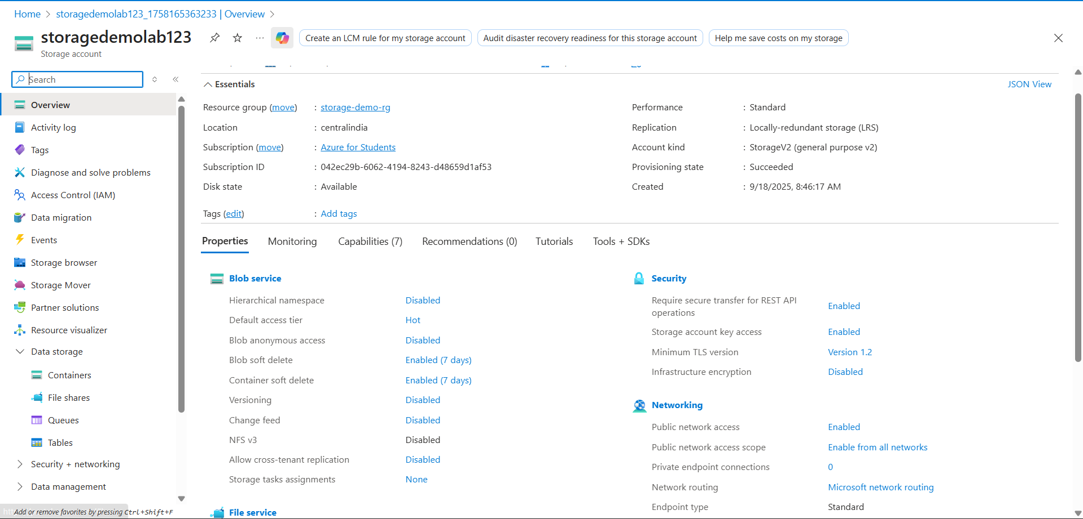

Containerlab:

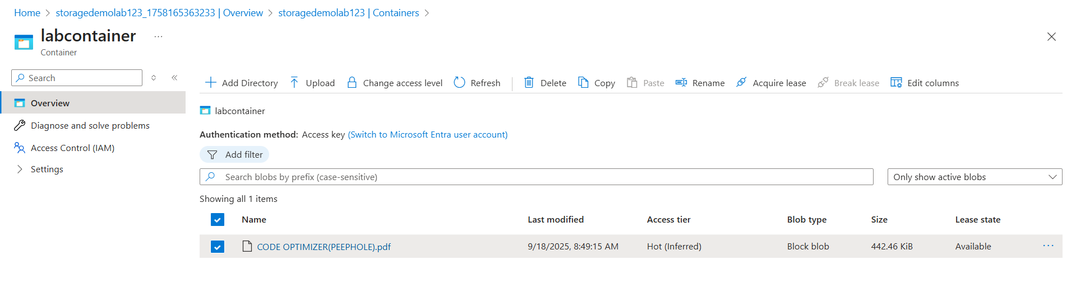

Uploaded blob:

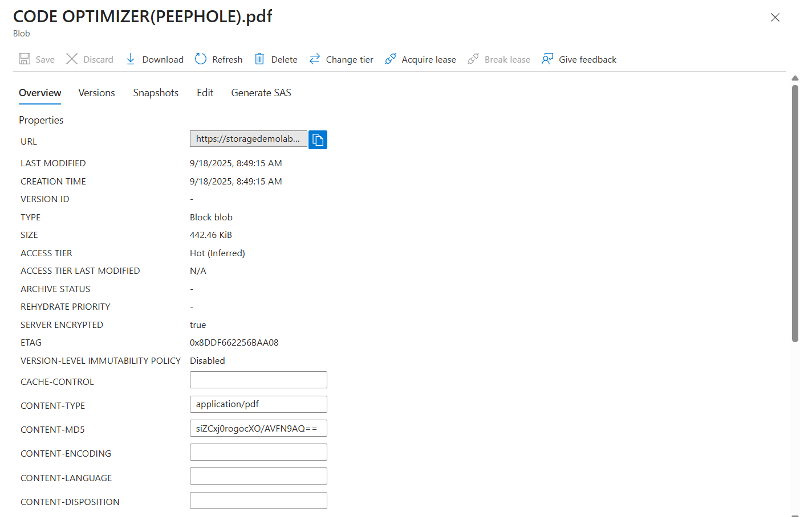

Result:

A Storage Service was successfully created in Azure. A file was uploaded to a blob container and accessed via its public URL/SAS URL, thus demonstrating Storage as a Service (SaaS) functionality.